
Mobile Application Dompet Kampus (e-Money)

Dosen : IKetut Gunawan, S.KOM, M.T.I
Kode/Mata Kuliah : KB1154/ Aplikasi Mobile Lanjutan
Bobot Mata Kuliah : 3 Sks
Prodi : Teknik Informatika
Pertemuan : 2

Cakupan Materi
Fase 2 Implementasikan ke Mobile Apps Flutter

Architecture

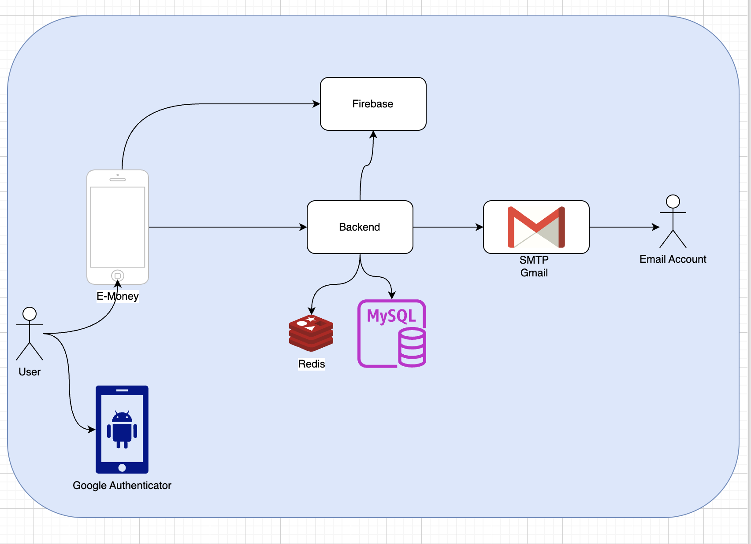

Prasyarat yang dibutuhkan
- Firebase
  - Firebase Project
  - Firebase Authentication
  - Firebase Service Account
- Gmail Setup SMTP
- Google Authenticator ( Download Apps)
- Postman
- Redis
- MySQL
- Go SDK
- Docker ( Optional )

Bab 0: Pendahuluan

Apa yang kita buat ?

Dompet Kampus Global adalah aplikasi e-money untuk lingkungan kampus yang memiliki fitur:
- Autentikasi Firebase (Google Sign-In + Email/Password)
- Verifikasi 2FA: Email OTP, Google Authenticator (TOTP), Push Notification
- Dashboard saldo & transaksi
- Transfer uang (sesama pengguna & antarbank)
- Top Up saldo (Virtual Account, Kartu, Retail)
- Pembayaran QRIS
- Deeplink dari e-commerce eksternal
- Riwayat transaksi
- Promo & reward

Tech Stack

Layer | Teknologi
Framework | Flutter 3.x (Dart 3)
State Management | flutter_bloc + equatable
Navigation | go_router
DI | get_it
HTTP Client | Dio + pretty_dio_logger
Firebase | Firebase_auth + firebase_message
Storage | flutter_secure_storage
QR Scan | mobile_scanner
Formating | intl

Ringkasan Tumpukan Teknologi (Tech Stack)
Layer | Teknologi
State Management | flutter_bloc (Bloc, BlocBuilder, BlocListener, BlocConsumer)
Dependency Injection | get_it (service locator "sl")
Routing | go_router (GoRoute, ShellRoute, context.go/push/pop)
Networking | Dio (ApiClient) → backend Go (Gin)
Auth | firebase_auth (Email/Password & Google Sign-In) + JWT backend
Local Storage | flutter_secure_storage
Arsitektur | Clean Architecture: domain / data / presentation / core / injection

Daftar Halaman (Screen) yang Dibahas
No | Halaman | Route | Deskripsi Singkat
1 | Splash | / | Landing screen — cek sesi login, tombol Daftar/Masuk
2 | Register | /register | Form pendaftaran akun baru
3 | Verify Email | /verify-email | Input kode OTP verifikasi email
4 | Login | /login | Login Email/Password & Google Sign-In
5 | Setup 2FA | /setup-2fa | Pilih metode verifikasi 2 langkah
6 | 2FA Email OTP | /2fa/smtp | Verifikasi kode OTP via email (SMTP)
7 | 2FA Authenticator | /2fa/totp | Verifikasi via Google Authenticator (TOTP)
8 | 2FA Notifikasi | /2fa/notif | Verifikasi via push notification (FCM)
9 | Home / Dashboard | /home | Saldo, quick action, transaksi terakhir
10 | Riwayat | /history | Daftar seluruh transaksi + filter
11 | Promo | /promo | Daftar promo & reward
12 | Akun | /akun | Profil, keamanan (2FA), logout
13 | Transfer | /transfer | Pilih penerima (sesama DKG / bank)
14 | Transfer Nominal | /transfer/amount | Input nominal transfer
15 | Transfer Konfirmasi | /transfer/confirm | Review sebelum bayar
16 | Top Up | /topup | Isi saldo
17 | Payment QR | /payment | Scan kode QRIS
18 | PIN | /pin | Input PIN keamanan transaksi
19 | Success | /success | Konfirmasi transaksi berhasil
20 | Merchant Checkout | /merchant | Simulasi checkout e-commerce eksternal

Setup Project
- NEW FIREBASE PROJECT
  - AUTHENTICATION
  - SERVICE ACCOUNT ( Download service_account.json)
  - API Key
- Database MySQL
  - Setup database mysql ( user , password , database name )

Bab 1: Preview Fitur Aplikasi

Splash Screen | Login Screen
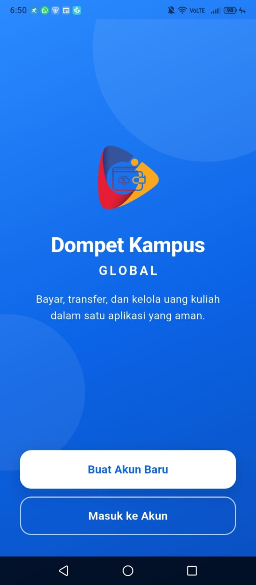 | 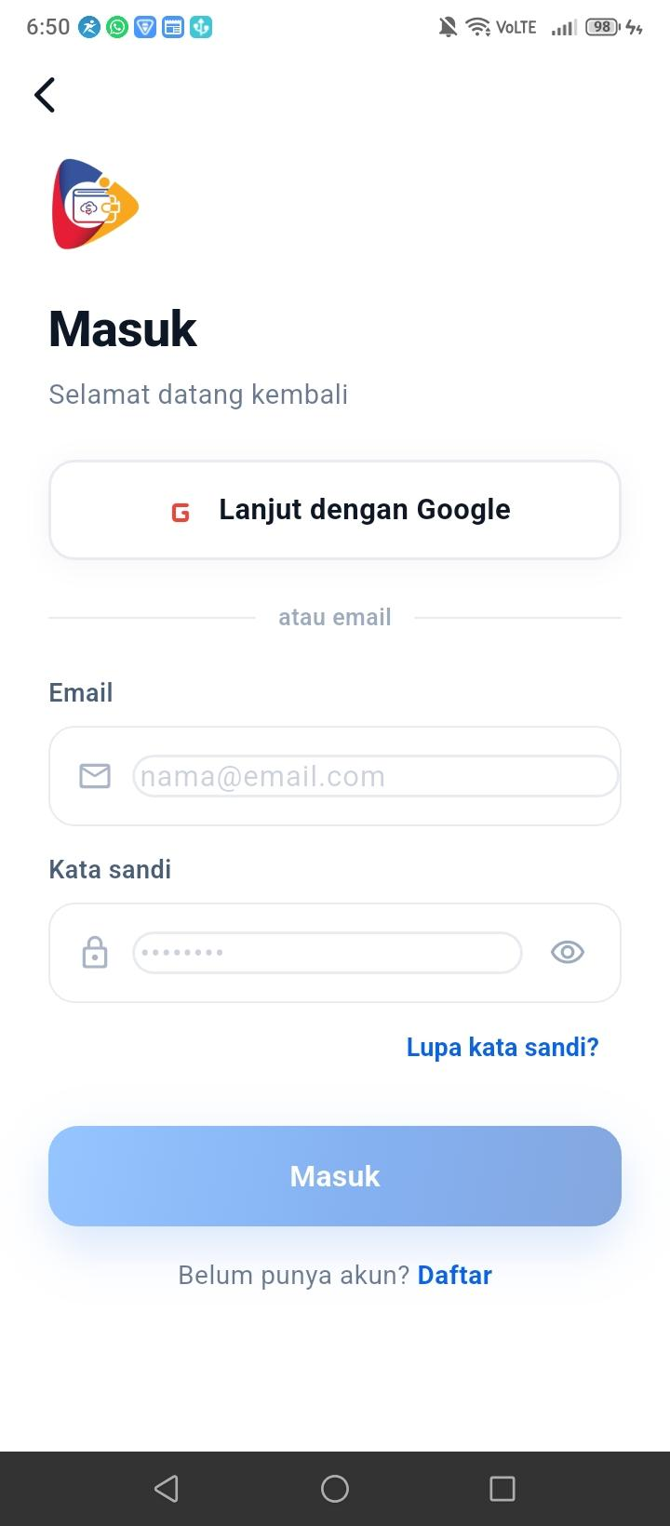
splash_screen.dart

Registrasi Akun | Verifikasi OTP melalui e-mail
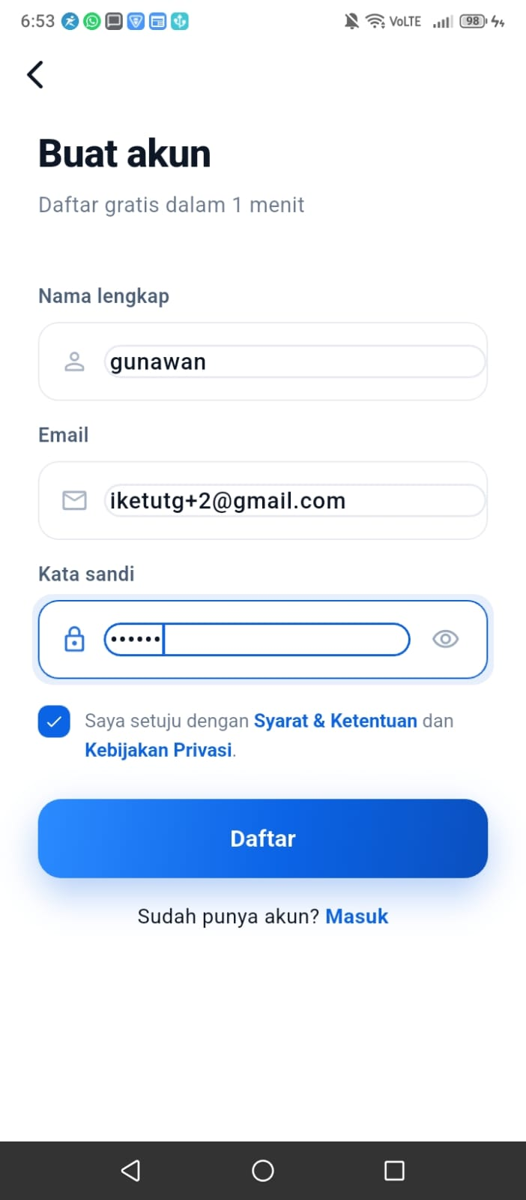 | 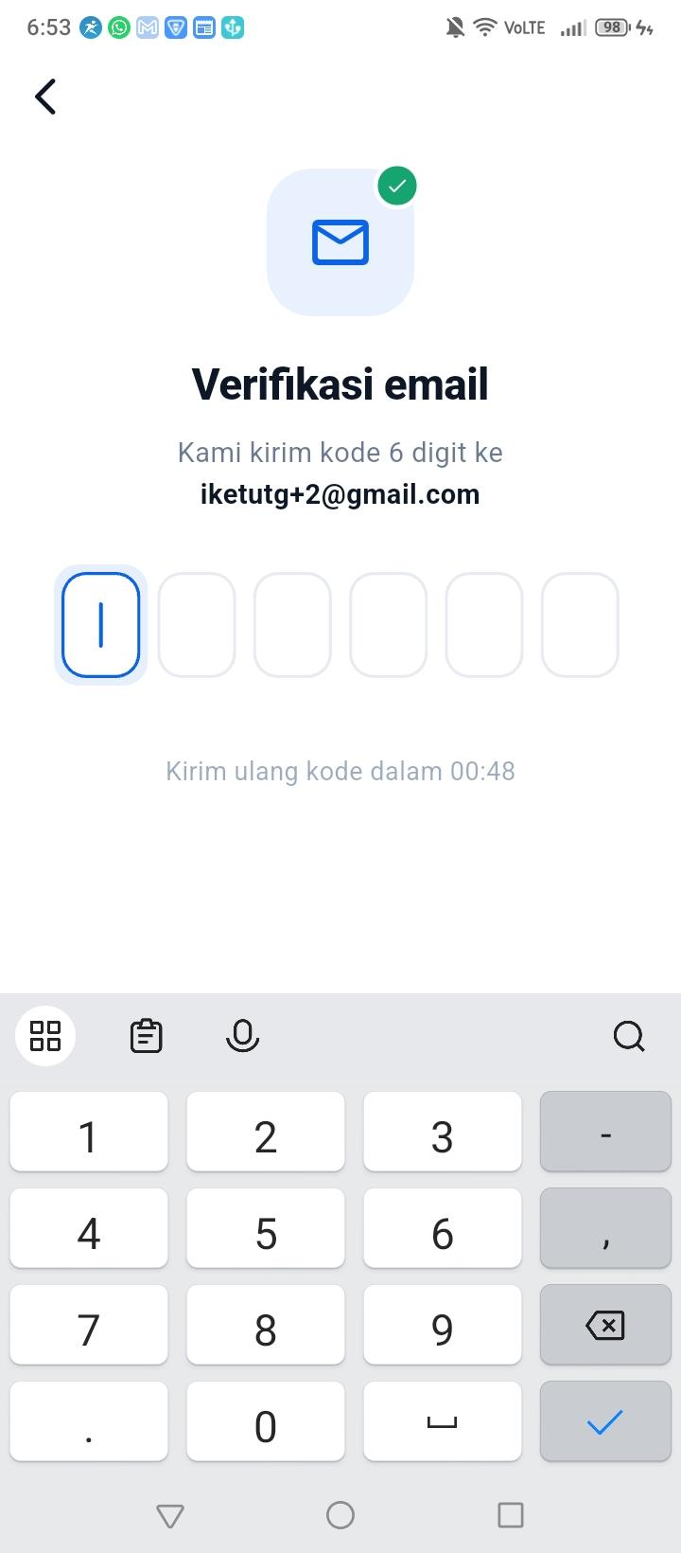

2FA | TOTP
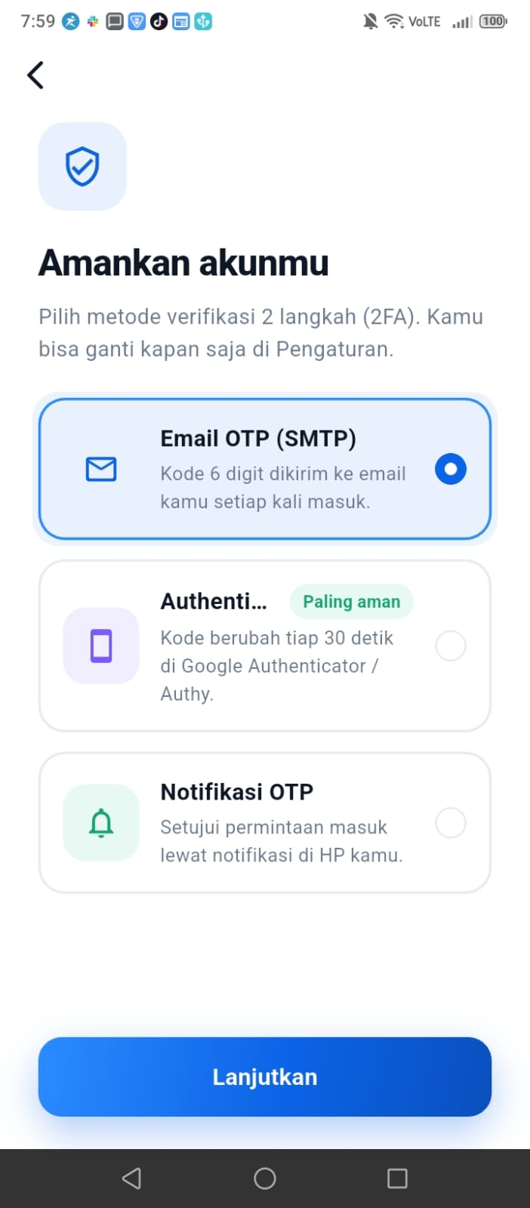 | 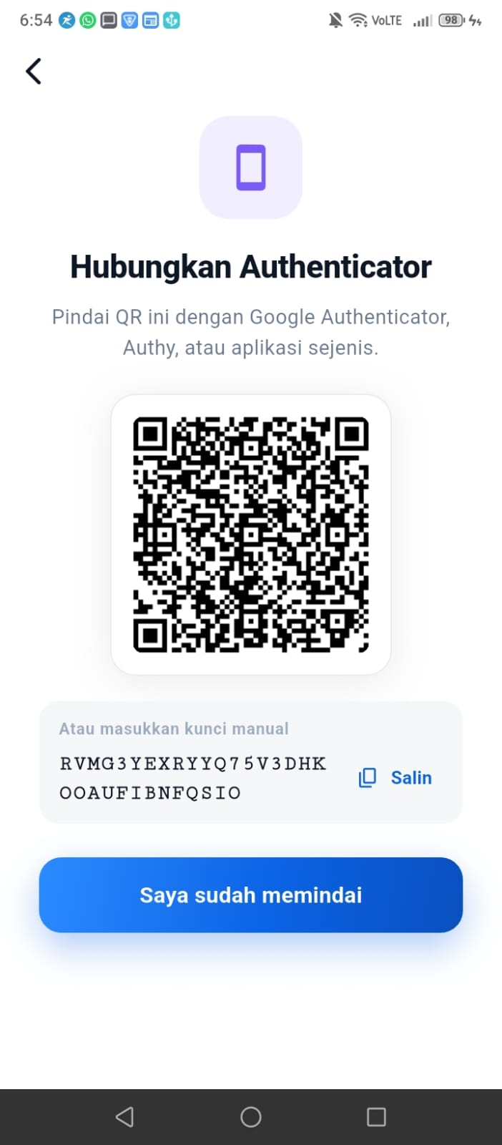

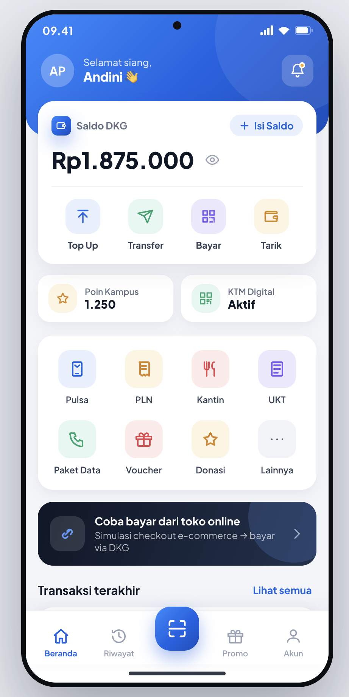 | 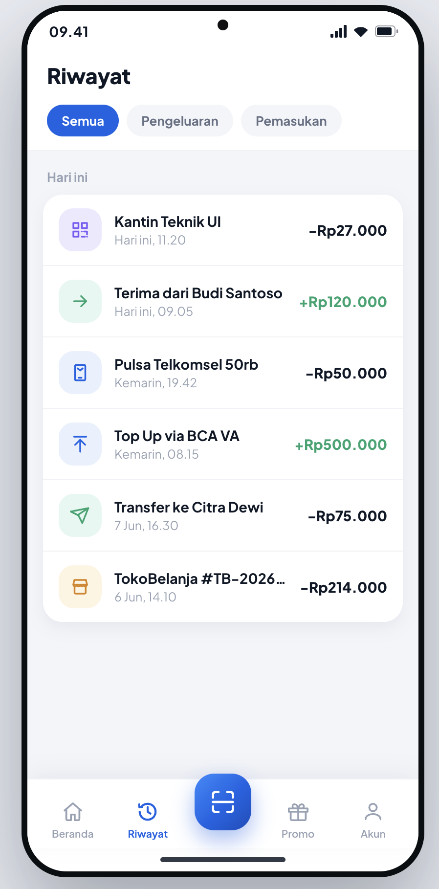

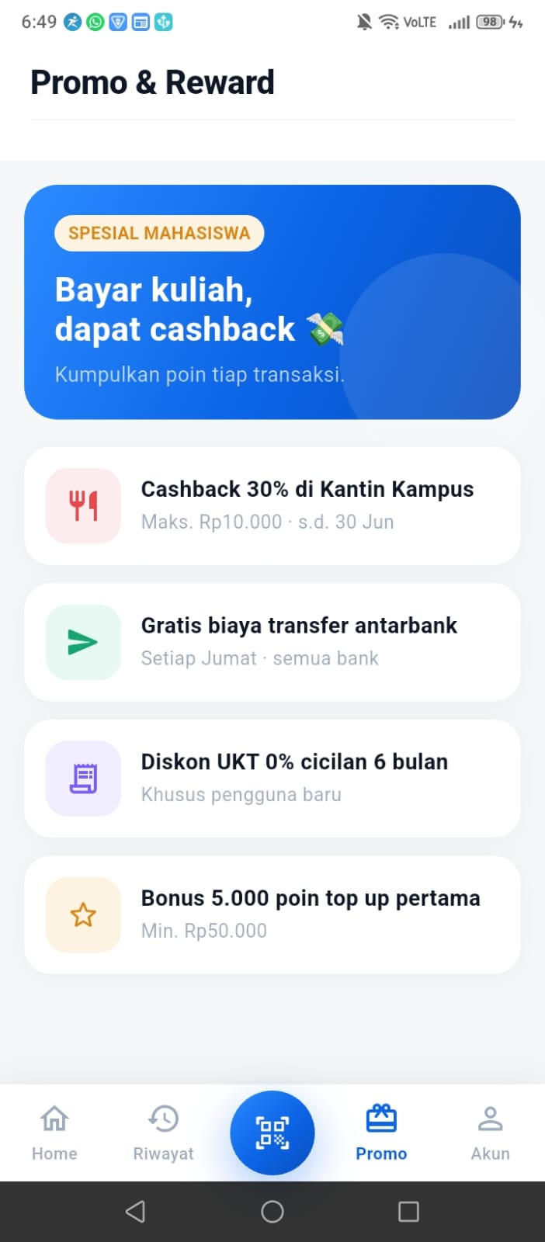 | 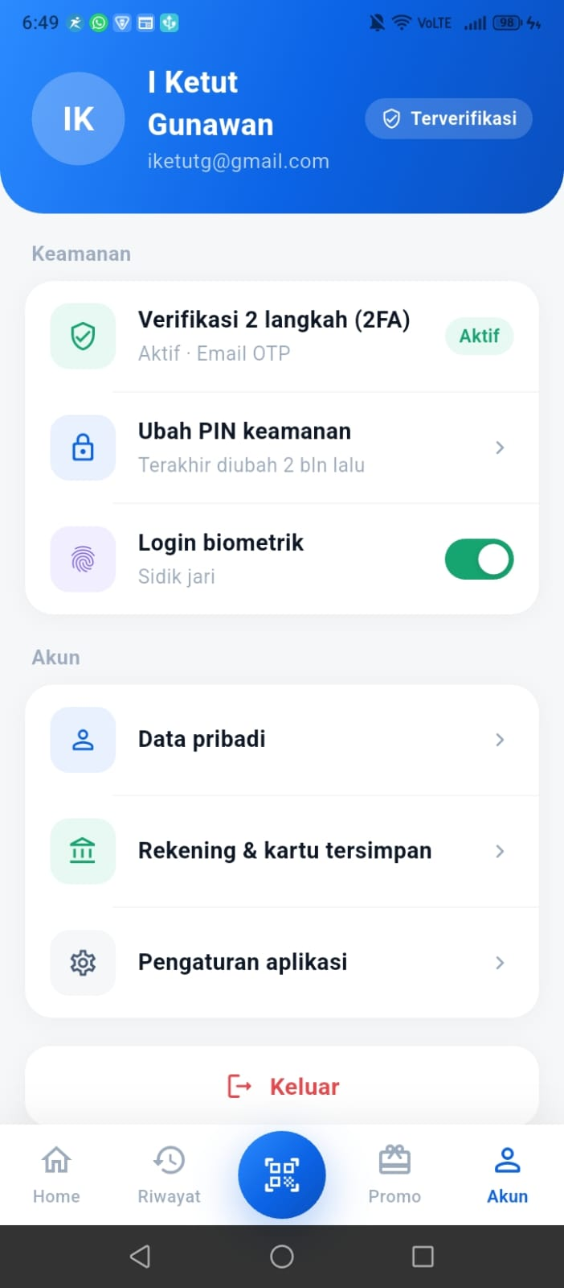

Bab 2: Flutter project configuration file (pubspec.yaml)

name: dompet_kampus_global
description: "Aplikasi e-money Dompet Kampus Global — bayar, transfer, dan kelola uang kuliah."
publish_to: 'none'
version: 1.0.0+1

environment:
sdk: '>=3.0.0 <4.0.0'

dependencies:
flutter:
sdk: flutter

# State Management
flutter_bloc: ^9.0.0
equatable: ^2.0.5

# Dependency Injection
get_it: ^8.0.2

# Navigation
go_router: ^14.8.1

# Network
dio: ^5.7.0
pretty_dio_logger: ^1.4.0

# Firebase
firebase_core: ^3.12.1
firebase_auth: ^5.5.2
firebase_messaging: ^15.2.4
google_sign_in: ^6.2.2

# Local Storage
flutter_secure_storage: ^9.2.2
shared_preferences: ^2.3.4

# QR / Camera
mobile_scanner: ^7.0.0

# UI Helpers
cached_network_image: ^3.4.1
shimmer: ^3.0.0
intl: ^0.19.0

# Icons
cupertino_icons: ^1.0.8

dev_dependencies:
flutter_test:
sdk: flutter
flutter_lints: ^6.0.0

flutter:
uses-material-design: true
assets:
- assets/images/
- assets/icons/

Bab 3: Setup project

3.1 Create Database
Membuat Create Database

3.2 Create Project Firebase Console e-money
# 1. Project e-money
- Add provider Android sesuai dengan nama package di Flutter

# 2. Enable Authentication

# 3. Download service-account.json pada service

3.2 Create App Password ( SMTP email )
# 1. Enable 2FA pada email
# 2. Create app password
# 2. Create app password

- Add provider Android sesuai dengan nama package di Flutter

3.3 Firebase Setup (FlutterFire CLI)
Jalankan command berikut secara berurutan di terminal:
# 1. Install FlutterFire CLI
dart pub global activate flutterfire_cli

# 2. Login ke Firebase
firebase login

# 3. Configure project (pilih project Firebase yang sudah dibuat)
flutterfire configure

# 4. Ini akan generate file: lib/firebase_options.dart

Bab 3: Peta Navigasi & Alur Aplikasi

Routing aplikasi didefinisikan dalam satu file: lib/core/router/app_router.dart, menggunakan GoRouter. Ada 3 kelompok route:
- Route mandiri (auth/onboarding): /, /login, /register, /verify-email, /setup-2fa, /2fa/smtp, /2fa/totp, /2fa/notif
- ShellRoute dengan bottom tab bar: /home, /history, /promo, /akun — dibungkus AppTabBar agar tab bar selalu tampil
- Route transaksi (tanpa tab bar): /topup, /transfer, /transfer/amount, /transfer/confirm, /payment, /pin, /success, /merchant
Setiap route dibungkus dengan salah satu helper provider berikut agar BLoC yang dibutuhkan halaman tersebut tersedia melalui context.read<...>():
Helper | BLoC yang disediakan | Dipakai oleh
_withAuth | AuthBloc | / (Splash), /login
_withOtp | AuthBloc, OtpBloc | /2fa/smtp, /2fa/totp, /2fa/notif
_withAccount | AuthBloc, AccountBloc | Shell (/home, /history, /promo, /akun), /transfer/amount, /success
_withPayment | AuthBloc, AccountBloc, PaymentBloc | /topup, /pin, /merchant

Alur Pengguna Baru (Registrasi -> Verifikasi -> 2FA -> Home)
/ (Splash)
+- tap "Buat Akun Baru"
+- /register
+- isi form -> Firebase createUser -> POST /v1/auth/register
+- /verify-email
+- input kode OTP 6 digit -> POST /v1/auth/verify-email-otp
+- /setup-2fa
+- pilih salah satu metode 2FA (mode: "setup")
|- /2fa/smtp -> verifikasi -> /home
|- /2fa/totp -> scan QR -> verifikasi -> /home
+- /2fa/notif -> approve notifikasi -> /home

Alur Pengguna Lama (Login -> 2FA -> Home)
/ (Splash)
|- AuthCheckRequested -> sudah login & 2FA terverifikasi -> /home (otomatis)
+- tap "Masuk ke Akun"
+- /login
+- Firebase signIn (Email/Password atau Google)
+- POST /v1/auth/verify-token
|- AuthNeedsVerification -> /2fa/smtp (mode: "login") -> /home
+- AuthAuthenticated -> /home

Alur Transaksi (Home -> Transfer/TopUp/QR -> PIN -> Success)
/home
|- Top Up / Tarik -> /topup --(PaymentBloc.PaymentTopupRequested)--> /success
|- Transfer -> /transfer -> /transfer/amount -> /transfer/confirm
| +- /pin (kind: transfer)
|- Bayar (scan QRIS) -> /payment -> bottom-sheet "Bayar Sekarang" -> /pin (kind: payment)
+- Banner e-commerce -> /merchant -> "Bayar Rp..." -> /pin (kind: deeplink)

/pin
+- input 6 digit PIN -> PaymentBloc.PaymentTransferRequested / PaymentTopupRequested
+- /success -> tombol "Selesai" -> /home

Diagram sequence lengkap untuk alur Registrasi, Verifikasi Email, dan Setup 2FA (termasuk interaksi dengan backend Go, Redis, Firebase Admin SDK, SMTP, dan FCM) tersedia di backend-emoney/docs/registration_2fa_flow.md.

2. Detail Setiap Halaman

2.1. Halaman Awal (Splash)
Route: / | Widget: SplashPage
Lokasi file:
lib/presentation/pages/splash/splash_page.dart

BLoC / Dependency yang digunakan:
- AuthBloc — disediakan oleh helper _withAuth pada route "/". Dipakai untuk mengecek status sesi login saat aplikasi dibuka.
Struktur & Komponen UI:
- Scaffold dengan background gradient AppColors.primaryGradient (full screen)
- Dua lingkaran dekoratif transparan (Positioned + Container shape: circle)
- AppLogo(size: 92, light: true) — logo versi putih untuk background gelap
- Judul "Dompet Kampus" + sub-judul "GLOBAL" + tagline aplikasi
- Dua tombol aksi: "Buat Akun Baru" (varian putih) dan "Masuk ke Akun" (varian outline putih)
- Dibungkus BlocListener<AuthBloc, AuthState> yang memicu navigasi otomatis jika user sudah login
Kode Penting:
class _SplashPageState extends State<SplashPage> {
@override
void initState() {
super.initState();
context.read<AuthBloc>().add(AuthCheckRequested());
}

@override
Widget build(BuildContext context) {
return BlocListener<AuthBloc, AuthState>(
listener: (context, state) {
if (state is AuthAuthenticated) {
context.go('/home');
} else if (state is AuthUnauthenticated) {
// Tetap di splash, tampilkan tombol welcome
}
},
child: Scaffold(
body: Container(
decoration: const BoxDecoration(gradient: AppColors.primaryGradient),
child: SafeArea(
child: Column(
children: [
const AppLogo(size: 92, light: true),
const Text('Dompet Kampus', style: TextStyle(fontSize: 30, ...)),
const Text('GLOBAL', style: TextStyle(fontSize: 18, letterSpacing: 3, ...)),
const Text('Bayar, transfer, dan kelola uang kuliah\n'
'dalam satu aplikasi yang aman.'),
AppButton(
label: 'Buat Akun Baru',
variant: AppButtonVariant.white,
onPressed: () => context.push('/register'),
),
AppButton(
label: 'Masuk ke Akun',
variant: AppButtonVariant.outlineWhite,
onPressed: () => context.push('/login'),
),
],
),
),
),
),
);
}
}

Alur Navigasi:
- Masuk dari: Route awal aplikasi (initialLocation: "/"). Selalu menjadi halaman pertama yang terbuka.
- Keluar ke: AuthCheckRequested mengirim AuthBloc.add() saat initState; jika state hasil-nya AuthAuthenticated -> otomatis context.go('/home'). Jika belum login (AuthUnauthenticated), pengguna tetap di Splash dan memilih: tap "Buat Akun Baru" -> context.push('/register'), atau tap "Masuk ke Akun" -> context.push('/login').

2.2. Halaman Registrasi
Route: /register | Widget: RegisterPage
Lokasi file:
lib/presentation/pages/auth/register_page.dart

BLoC / Dependency yang digunakan:
- FirebaseAuth.instance — createUserWithEmailAndPassword() & updateDisplayName() (Firebase Client SDK)
- RegisterWithOtpUsecase (via sl<>()) — memanggil POST /v1/auth/register di backend dengan firebase_token
- ServerFailure / NetworkFailure — exception kustom dari core/error/failures.dart untuk menampilkan pesan error yang sesuai
Struktur & Komponen UI:
- Tombol back (DkgIcons.arrowLeft) di kiri atas -> context.go('/')
- Judul "Buat akun" + sub-judul "Daftar gratis dalam 1 menit"
- AppField "Nama lengkap" (prefix icon DkgIcons.user)
- AppField "Email" (keyboardType emailAddress, prefix icon DkgIcons.mail)
- AppField "Kata sandi" (obscureText, toggle show/hide via DkgIcons.eye/eyeOff)
- Checkbox custom "Saya setuju dengan Syarat & Ketentuan dan Kebijakan Privasi" (state _agree, default true)
- Tombol "Daftar" (AppButton) — disabled jika _valid == false, menampilkan spinner saat _loading == true
- Link "Sudah punya akun? Masuk" -> context.go('/login')
Kode Penting:
bool get _valid => _name.length > 1 && _email.contains('@') && _pw.length >= 6 && _agree;

Future<void> _register() async {
setState(() => _loading = true);
try {
// 1. Buat akun di Firebase
final credential = await FirebaseAuth.instance.createUserWithEmailAndPassword(
email: _email,
password: _pw,
);
await credential.user?.updateDisplayName(_name);

// 2. Ambil Firebase ID Token lalu kirim ke backend
final idToken = await credential.user?.getIdToken();
if (idToken == null) throw Exception('Gagal mendapatkan token Firebase');

await sl<RegisterWithOtpUsecase>()(idToken);

// 3. Backend sudah buat user + kirim OTP ke email -> ke halaman verifikasi
if (mounted) context.go('/verify-email');
} on FirebaseAuthException catch (e) {
// tampilkan e.message via SnackBar (mis. "email-already-in-use")
} on ServerFailure catch (e) {
// tampilkan e.message dari backend
} on NetworkFailure catch (_) {
// tampilkan "Tidak ada koneksi internet."
} finally {
if (mounted) setState(() => _loading = false);
}
}

Alur Navigasi:
- Masuk dari: Dari Splash ("/"), tombol "Buat Akun Baru".
- Keluar ke: Setelah _register() sukses -> context.go('/verify-email'). Tombol back atau gagal dibatalkan -> context.go('/'). Link "Masuk" -> context.go('/login').

2.3. Halaman Verifikasi Email
Route: /verify-email | Widget: VerifyEmailPage
Lokasi file:
lib/presentation/pages/auth/verify_email_page.dart

BLoC / Dependency yang digunakan:
- VerifyEmailOtpUsecase (via sl<>()) — POST /v1/auth/verify-email-otp { code }
- SendOtpEmailUsecase (via sl<>()) — POST /v1/otp/send-email, dipanggil saat tombol "Kirim ulang kode" ditekan
- FirebaseAuth.instance.currentUser — untuk menampilkan alamat email tujuan
Struktur & Komponen UI:
- Tombol back -> context.go('/register')
- Icon amplop (DkgIcons.mail) dengan badge centang hijau di pojok
- Judul "Verifikasi email" + teks "Kami kirim kode 6 digit ke <email>"
- Widget CodeInput — 6 kotak input digit, auto-focus & auto-submit saat panjang == 6
- Indikator loading (CircularProgressIndicator) saat proses verifikasi
- Pesan error merah "Kode salah atau sudah kadaluarsa" jika error_code == "INVALID_OTP", input otomatis dikosongkan setelah 650ms
- Countdown 60 detik; setelah habis, tombol "Kirim ulang kode" muncul
Kode Penting:
void _onCodeChanged(String value) {
setState(() { _code = value; _hasError = false; _errorMessage = null; });
if (value.length == 6) _verify(value);
}

Future<void> _verify(String code) async {
setState(() => _loading = true);
try {
await sl<VerifyEmailOtpUsecase>()(code);
if (mounted) context.go('/setup-2fa');
} on ServerFailure catch (e) {
final isInvalidOtp = e.errorCode == 'INVALID_OTP';
setState(() {
_hasError = true;
_errorMessage = isInvalidOtp ? 'Kode salah atau sudah kadaluarsa' : e.message;
});
Future.delayed(const Duration(milliseconds: 650), () {
if (mounted) setState(() { _code = ''; _hasError = false; });
});
} finally {
if (mounted) setState(() => _loading = false);
}
}

Future<void> _resend() async {
await sl<SendOtpEmailUsecase>()();
_startTimer(); // reset countdown ke 60 detik
}

Alur Navigasi:
- Masuk dari: Dari Register, otomatis setelah POST /v1/auth/register sukses.
- Keluar ke: Jika kode OTP benar -> context.go('/setup-2fa'). Tombol back -> context.go('/register').

2.4. Halaman Login
Route: /login | Widget: LoginPage
Lokasi file:
lib/presentation/pages/auth/login_page.dart

BLoC / Dependency yang digunakan:
AuthBloc — event AuthLoginWithFirebase(idToken), state AuthLoading / AuthAuthenticated / AuthNeedsVerification / AuthError
FirebaseAuth.instance — signInWithEmailAndPassword() & signInWithCredential() (Google)
GoogleSignIn — alur Google Sign-In, dengan signOut() dulu agar dialog pilih akun selalu muncul
Struktur & Komponen UI:
Tombol back -> context.go('/')
AppLogo + judul "Masuk" + sub-judul "Selamat datang kembali"
Tombol "Lanjut dengan Google" — BlocBuilder menampilkan spinner "Menghubungkan…" saat AuthLoading atau _gLoading
Divider "atau email"
AppField Email & Kata sandi (dengan toggle show/hide)
Link "Lupa kata sandi?"
Tombol "Masuk" (AppButton, isLoading dari state is AuthLoading), disabled jika _valid == false
Link "Belum punya akun? Daftar" -> context.go('/register')
BlocListener<AuthBloc, AuthState> menangani hasil login dan navigasi
Kode Penting:
Future<void> _loginWithGoogle() async {
setState(() => _gLoading = true);
final googleSignIn = GoogleSignIn();
await googleSignIn.signOut(); // agar dialog pilih akun selalu muncul
final googleUser = await googleSignIn.signIn();
if (googleUser == null) { setState(() => _gLoading = false); return; }

final googleAuth = await googleUser.authentication;
final credential = GoogleAuthProvider.credential(
accessToken: googleAuth.accessToken,
idToken: googleAuth.idToken,
);
final userCredential = await FirebaseAuth.instance.signInWithCredential(credential);
final idToken = await userCredential.user?.getIdToken();
if (idToken != null && mounted) {
context.read<AuthBloc>().add(AuthLoginWithFirebase(idToken));
}
}

Future<void> _loginWithEmail() async {
final userCredential = await FirebaseAuth.instance.signInWithEmailAndPassword(
email: _email, password: _pw,
);
final idToken = await userCredential.user?.getIdToken();
if (idToken != null && mounted) {
context.read<AuthBloc>().add(AuthLoginWithFirebase(idToken));
}
}

// BlocListener<AuthBloc, AuthState>
listener: (context, state) {
if (state is AuthNeedsVerification) {
context.go('/2fa/smtp');
} else if (state is AuthAuthenticated) {
context.go('/home');
} else if (state is AuthError) {
ScaffoldMessenger.of(context).showSnackBar(SnackBar(content: Text(state.message)));
}
}

Alur Navigasi:
Masuk dari: Dari Splash ("/"), tombol "Masuk ke Akun".
Keluar ke: AuthLoginWithFirebase mengirim idToken ke POST /v1/auth/verify-token. Jika 2FA belum aktif/diverifikasi -> AuthNeedsVerification -> context.go('/2fa/smtp') (mode default "login"). Jika sukses penuh -> AuthAuthenticated -> context.go('/home'). Tombol back -> context.go('/'). Link "Daftar" -> context.go('/register').

2.5. Halaman Setup 2FA
Route: /setup-2fa | Widget: Setup2FAPage
Lokasi file:
lib/presentation/pages/auth/setup_2fa_page.dart

BLoC / Dependency yang digunakan:
Tidak ada BLoC khusus — halaman ini murni navigasi dengan local state _selected (default "smtp"). Daftar metode didefinisikan sebagai const _twoFaMethods.
Struktur & Komponen UI:
Tombol back: context.canPop() ? context.pop() : context.go('/akun') — kembali ke halaman sebelumnya jika ada di back stack, atau ke /akun jika diakses langsung dari menu Akun
Icon shield (DkgIcons.shieldCheck) + judul "Amankan akunmu"
Daftar 3 metode 2FA, masing-masing AnimatedContainer dengan radio indicator:
- Email OTP (SMTP): icon mail, tone biru, route "/2fa/smtp"
- Authenticator (TOTP): icon smartphone, tone ungu, badge "Paling aman", route "/2fa/totp"
- Notifikasi OTP: icon bell, tone hijau, route "/2fa/notif"
Tombol "Lanjutkan" di bawah — menavigasi ke route metode terpilih dengan extra {'mode': 'setup'}
Kode Penting:
const _twoFaMethods = [
_TwoFaMethod(key: 'smtp', icon: DkgIcons.mail, tone: 'blue',
title: 'Email OTP (SMTP)',
desc: 'Kode 6 digit dikirim ke email kamu setiap kali masuk.',
route: '/2fa/smtp'),
_TwoFaMethod(key: 'totp', icon: DkgIcons.smartphone, tone: 'violet',
title: 'Authenticator (TOTP)',
desc: 'Kode berubah tiap 30 detik di Google Authenticator / Authy.',
route: '/2fa/totp', badge: 'Paling aman'),
_TwoFaMethod(key: 'notif', icon: DkgIcons.bell, tone: 'green',
title: 'Notifikasi OTP',
desc: 'Setujui permintaan masuk lewat notifikasi di HP kamu.',
route: '/2fa/notif'),
];

// Tombol back
IconButton(
icon: const Icon(DkgIcons.arrowLeft, color: AppColors.ink),
onPressed: () => context.canPop() ? context.pop() : context.go('/akun'),
),

// Tombol Lanjutkan
AppButton(
label: 'Lanjutkan',
onPressed: () {
final m = _twoFaMethods.firstWhere((m) => m.key == _selected);
context.go(m.route, extra: {'mode': 'setup'});
},
),

Alur Navigasi:
Masuk dari: Dari Verify Email (alur registrasi baru, otomatis), atau dari halaman Akun (/akun) — menu "Verifikasi 2 langkah (2FA)".
Keluar ke: context.go(m.route, extra: {'mode': 'setup'}) menuju salah satu dari /2fa/smtp, /2fa/totp, atau /2fa/notif sesuai metode terpilih. Tombol back -> halaman sebelumnya, atau /akun.

2.6. 2FA — Email OTP (SMTP)
Route: /2fa/smtp | Widget: TwoFASmtpPage
Lokasi file:
lib/presentation/pages/auth/twofa_smtp_page.dart

BLoC / Dependency yang digunakan:
OtpBloc — event OtpSendEmail (kirim kode), OtpConfirm(code, otpType: "email") (verifikasi)
AuthBloc — saat mode "login", AuthCheckRequested dipanggil ulang setelah OTP terverifikasi agar status auth_verified ter-refresh
Struktur & Komponen UI:
Menerima parameter "mode" ('login' atau 'setup') dari extra GoRouter
Tombol back -> context.go(mode == 'setup' ? '/setup-2fa' : '/login')
FeatureIcon amplop biru + judul "Masukkan Email OTP"
CodeInput 6 digit — auto-submit OtpConfirm saat panjang == 6
Pesan error merah "Kode salah" jika OtpInvalid, input dikosongkan setelah 650ms
Info box kuning "Cek email inbox atau spam kamu"
Countdown AppConstants.otpResendSeconds detik -> tombol "Kirim ulang kode" (memicu ulang OtpSendEmail)
Kode Penting:
@override
void initState() {
super.initState();
context.read<OtpBloc>().add(OtpSendEmail()); // POST /v1/otp/send-email
_startTimer();
}

void _onCodeChanged(String v) {
setState(() { _code = v; _hasError = false; });
if (v.length == 6) {
context.read<OtpBloc>().add(OtpConfirm(code: v, otpType: AppConstants.otpTypeEmail));
}
}

// BlocListener<OtpBloc, OtpState>
listener: (context, state) {
if (state is OtpVerified) {
if (widget.mode == 'setup') {
context.go('/home');
} else {
context.read<AuthBloc>().add(AuthCheckRequested());
context.go('/home');
}
} else if (state is OtpInvalid) {
setState(() => _hasError = true);
Future.delayed(const Duration(milliseconds: 650), () {
if (mounted) setState(() { _code = ''; _hasError = false; });
});
}
}

Alur Navigasi:
Masuk dari: Dari /setup-2fa dengan extra {'mode': 'setup'} (saat user memilih metode Email OTP), atau dari /login saat AuthBloc mengembalikan AuthNeedsVerification (mode default "login").
Keluar ke: Setelah POST /v1/otp/confirm sukses (OtpVerified) -> context.go('/home'). Tombol back -> /setup-2fa (mode setup) atau /login (mode login).

2.7. 2FA — Authenticator (TOTP)
Route: /2fa/totp | Widget: TwoFATotpPage
Lokasi file:
lib/presentation/pages/auth/twofa_totp_page.dart

BLoC / Dependency yang digunakan:
OtpBloc — event OtpRegisterTotp() (POST /v1/otp/totp/register, hanya mode "setup"), OtpVerifyTotp(code) (POST /v1/otp/totp/verify)
Clipboard (flutter/services) — menyalin secret key manual ke clipboard
Struktur & Komponen UI:
State machine _step: "loading" -> "scan" (hanya mode setup) -> "code"
Mode "login": langsung ke step "code" (skip scan, karena TOTP sudah terdaftar sebelumnya)
Step "scan": menampilkan QR code dari base64 (Image.memory + Uri.parse(qrCode).data!.contentAsBytes()), kotak "kunci manual" dengan tombol Salin (ikon berubah jadi centang hijau "Tersalin" selama 1.4 detik), tombol "Saya sudah memindai" -> pindah ke step "code"
Step "code": CodeInput 6 digit + circular countdown visual 30 detik ("Kode berganti dalam Xs")
Tombol back: jika di step code & mode setup -> kembali ke step scan; selain itu -> /setup-2fa (setup) atau /login (login)
Pesan error "Kode tidak cocok" jika OtpInvalid
Kode Penting:
@override
void initState() {
super.initState();
if (widget.mode == 'setup') {
context.read<OtpBloc>().add(OtpRegisterTotp()); // generate secret + QR
} else {
setState(() => _step = 'code');
}
_ticker = Timer.periodic(const Duration(seconds: 1), (_) {
setState(() => _ttl = _ttl <= 1 ? 30 : _ttl - 1);
});
}

void _onCodeChanged(String v) {
setState(() { _code = v; _hasError = false; });
if (v.length == 6) context.read<OtpBloc>().add(OtpVerifyTotp(v));
}

// BlocListener<OtpBloc, OtpState>
listener: (context, state) {
if (state is OtpTotpSetup) {
setState(() => _step = 'scan'); // tampilkan QR + secret
} else if (state is OtpTotpEnabled || state is OtpVerified) {
context.go('/home');
} else if (state is OtpInvalid) {
setState(() => _hasError = true);
Future.delayed(const Duration(milliseconds: 650), () {
if (mounted) setState(() { _code = ''; _hasError = false; });
});
}
}

// Tombol salin secret manual
TextButton.icon(
onPressed: () async {
await Clipboard.setData(ClipboardData(text: state.entity.secret));
setState(() => _copied = true);
Future.delayed(const Duration(milliseconds: 1400), () {
if (mounted) setState(() => _copied = false);
});
},
icon: Icon(_copied ? DkgIcons.check : DkgIcons.copy),
label: Text(_copied ? 'Tersalin' : 'Salin'),
)

Alur Navigasi:
Masuk dari: Dari /setup-2fa dengan extra {'mode': 'setup'}, atau dari alur login saat metode 2FA aktif adalah TOTP (mode "login").
Keluar ke: Setelah TOTP berhasil diaktifkan (OtpTotpEnabled, mode setup) atau diverifikasi (OtpVerified, mode login) -> context.go('/home'). Tombol back -> step "scan" (jika sedang setup), atau /setup-2fa / /login.

2.8. 2FA — Notifikasi Push (FCM)
Route: /2fa/notif | Widget: TwoFANotifPage
Lokasi file:
lib/presentation/pages/auth/twofa_notif_page.dart

BLoC / Dependency yang digunakan:
OtpBloc — event OtpSendFirebase() (POST /v1/otp/send-firebase, backend mengirim kode OTP via FCM push notification ke fcm_token user)
Struktur & Komponen UI:
initState memanggil OtpSendFirebase() agar backend langsung mengirim notifikasi
State _phase: "waiting" -> "approved"
FeatureIcon: Icons.notifications_outlined (waiting) berubah menjadi Icons.verified_user_outlined (approved), tone hijau
Judul & deskripsi berubah sesuai _phase ("Cek notifikasi kamu" / "Disetujui!")
Saat waiting: spinner kecil + teks "Menunggu persetujuan…"
Link "Tidak menerima notifikasi? Kirim ulang"
Tombol back -> mode "setup" ? /setup-2fa : /login
Kode Penting:
@override
void initState() {
super.initState();
context.read<OtpBloc>().add(OtpSendFirebase());
}

// BlocListener<OtpBloc, OtpState>
listener: (context, state) {
if (state is OtpVerified) {
setState(() => _phase = 'approved');
Future.delayed(const Duration(milliseconds: 900), () {
if (mounted) context.go('/home');
});
} else if (state is OtpError) {
ScaffoldMessenger.of(context).showSnackBar(
SnackBar(content: Text(state.message), backgroundColor: AppColors.red),
);
}
}

Alur Navigasi:
- Masuk dari: Dari /setup-2fa dengan extra {'mode': 'setup'}, atau dari alur login saat metode 2FA aktif adalah Notifikasi (mode "login").
- Keluar ke: Setelah notifikasi disetujui (OtpVerified) dan delay 900ms -> context.go('/home'). Tombol back -> /setup-2fa atau /login.

2.9. Dashboard (Home)
Route: /home | Widget: HomePage
Lokasi file:
lib/presentation/pages/home/home_page.dart

BLoC / Dependency yang digunakan:
AccountBloc — AccountLoadRequested (initState), AccountRefreshRequested (pull-to-refresh); state AccountLoaded berisi account.balance & transactions
AuthBloc — BlocBuilder dibaca untuk menampilkan nama user pada sapaan
Struktur & Komponen UI:
Header gradient (AppColors.primaryGradient) berisi avatar, sapaan "Selamat siang, {firstName}", dan ikon notifikasi
Balance Card melayang (Positioned, bottom: -46) di atas header — menampilkan saldo (CurrencyFormatter.format / maskBalance untuk toggle sembunyikan saldo), tombol "Isi Saldo", dan 4 quick action: Top Up, Transfer, Bayar, Tarik
Baris "Poin Kampus" dan "KTM Digital" (2 kartu info statis)
Grid 8 fitur (Pulsa, PLN, Kantin, UKT, Paket Data, Voucher, Donasi, Lainnya) — saat ini onTap: () {} (placeholder)
Banner gradient gelap "Coba bayar dari toko online" -> /merchant
Section "Transaksi terakhir" (4 item teratas dari txns) + link "Lihat semua" -> /history
RefreshIndicator membungkus seluruh body untuk pull-to-refresh
Kode Penting:
@override
void initState() {
super.initState();
context.read<AccountBloc>().add(AccountLoadRequested());
}

// Quick actions pada Balance Card
final actions = [
{'icon': Icons.north_rounded, 'label': 'Top Up', 'tone': 'blue', 'route': '/topup'},
{'icon': Icons.send_rounded, 'label': 'Transfer', 'tone': 'green', 'route': '/transfer'},
{'icon': Icons.qr_code_rounded, 'label': 'Bayar', 'tone': 'violet', 'route': '/payment'},
{'icon': Icons.south_rounded, 'label': 'Tarik', 'tone': 'amber', 'route': '/topup'},
];
// ... tiap action: onTap: () => context.go(a['route'] as String)

// Banner deeplink ke merchant
GestureDetector(
onTap: () => context.go('/merchant'),
child: Container(/* gradient gelap + teks "Coba bayar dari toko online" */),
)

// Pull to refresh
RefreshIndicator(
onRefresh: () async => context.read<AccountBloc>().add(AccountRefreshRequested()),
child: SingleChildScrollView(...),
)

// Link "Lihat semua"
GestureDetector(onTap: () => context.go('/history'), child: const Text('Lihat semua'))

Alur Navigasi:
Masuk dari: Tujuan akhir dari semua alur auth/2FA (AuthAuthenticated, OtpVerified, OtpTotpEnabled), atau tombol "Selesai" pada halaman Success. Merupakan tab default pada ShellRoute (bottom tab bar).
Keluar ke: Top Up / Tarik -> /topup, Transfer -> /transfer, Bayar -> /payment, banner e-commerce -> /merchant, "Lihat semua" -> /history. Bottom tab bar -> /history, /promo, /akun.

STEP  8 | Flow API

Alur Authentikasi

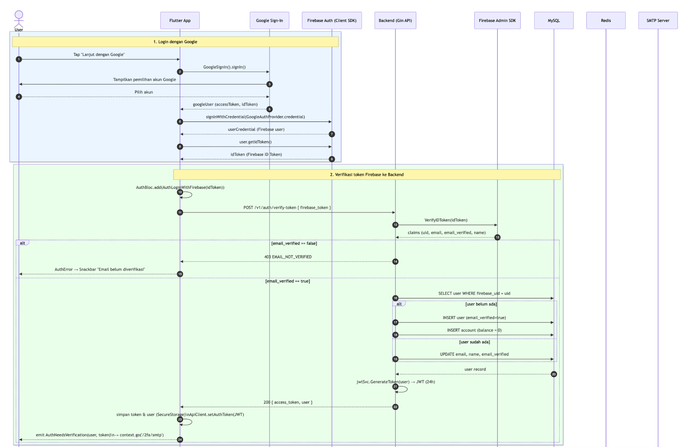

Alur Authentikasi

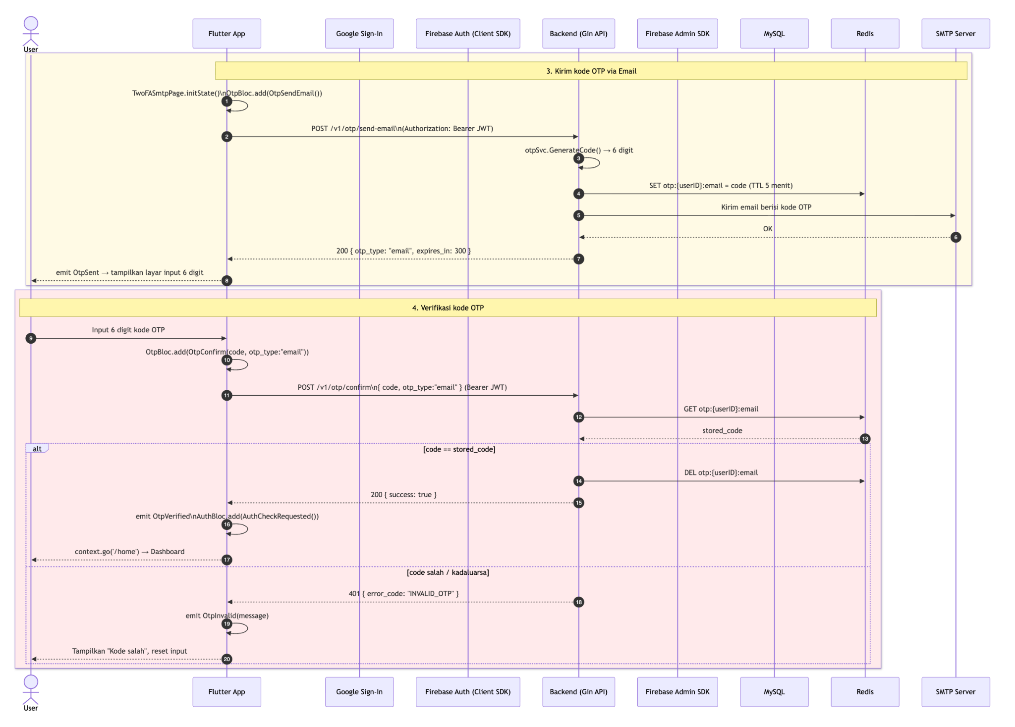

Alur OTP via Email Notification

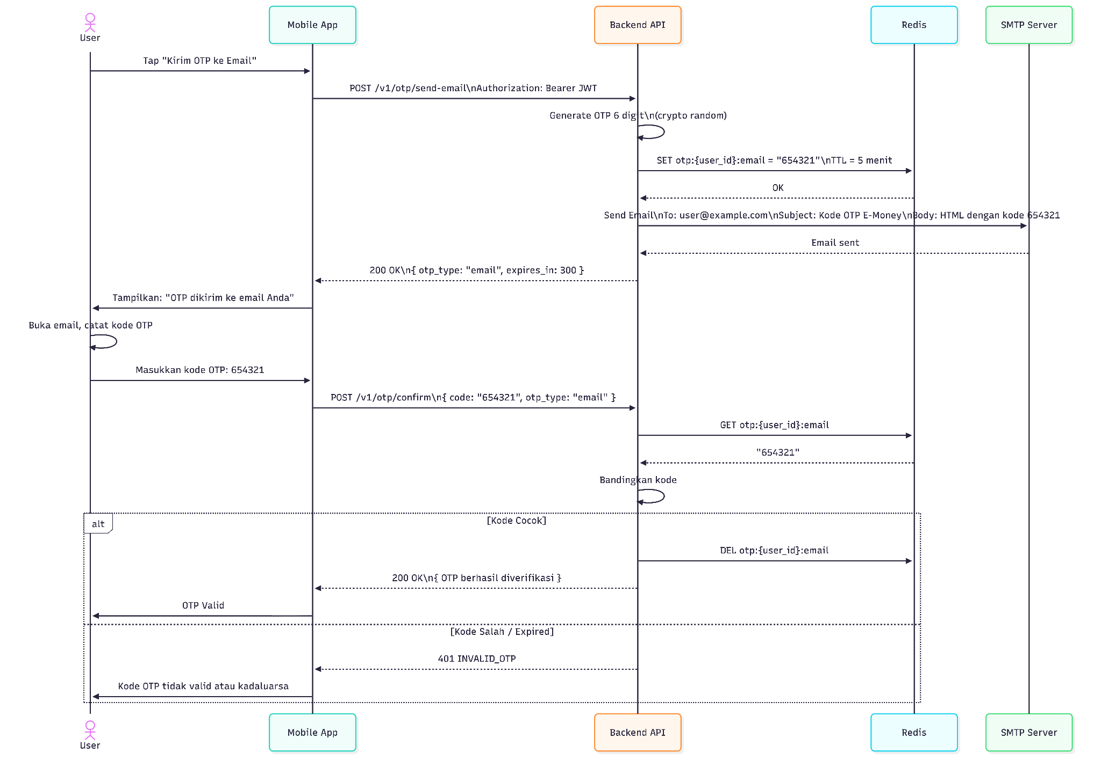

Alur TOTP — Registrasi Google Authenticator

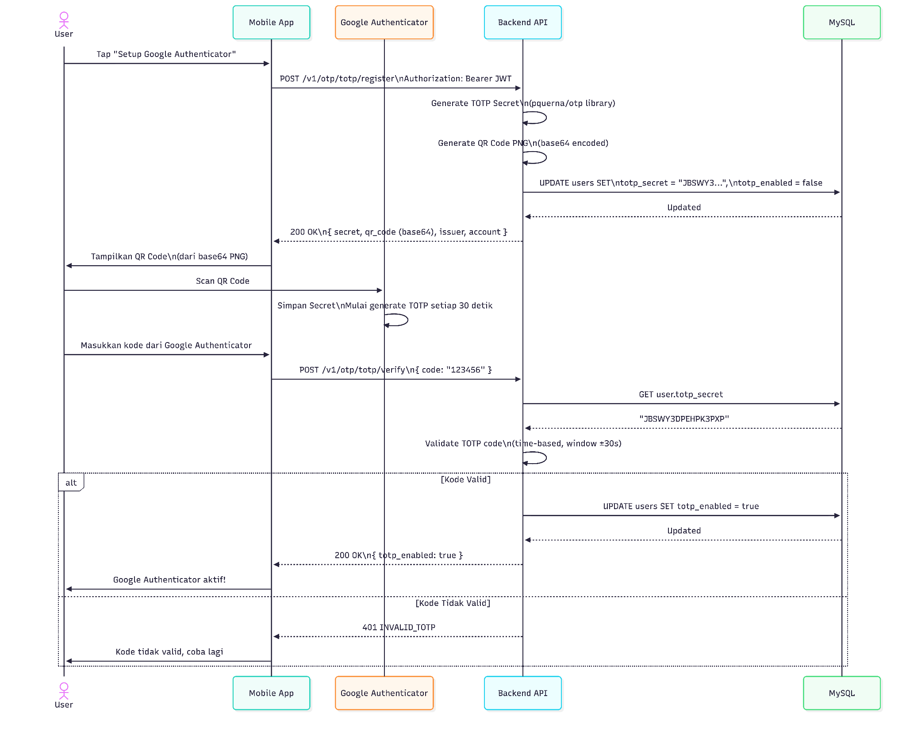

Alur Autentikasi

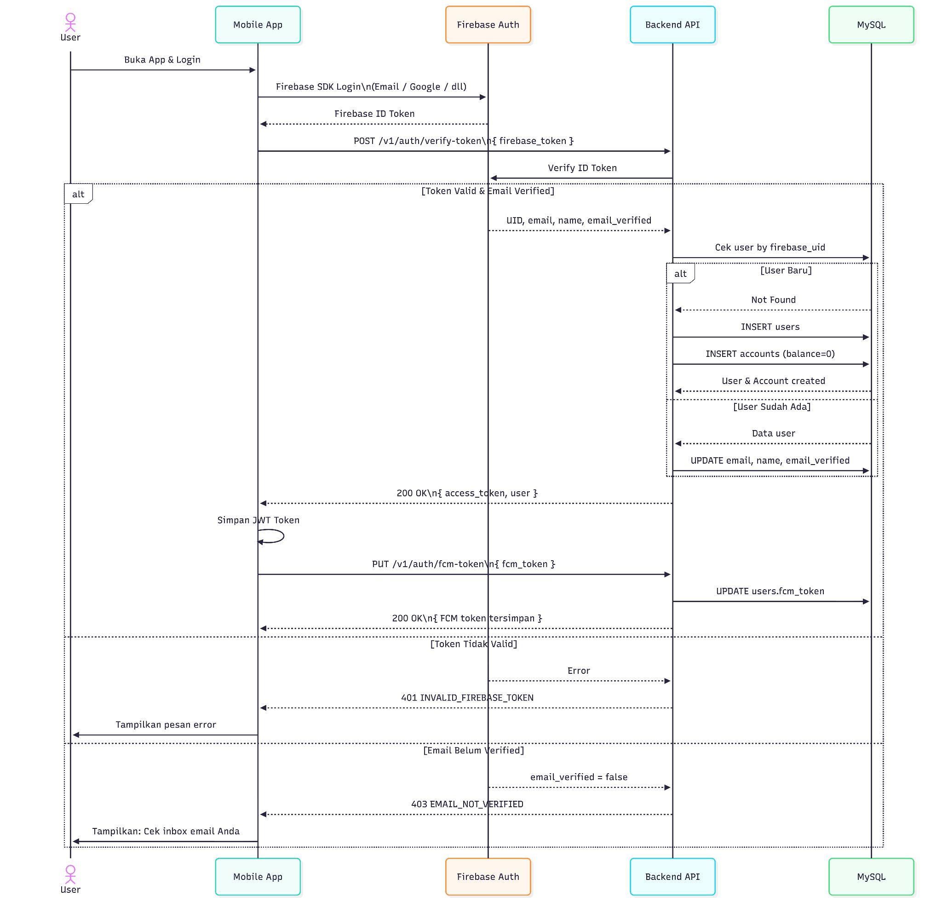

Alur Payment Transfer dengan OTP

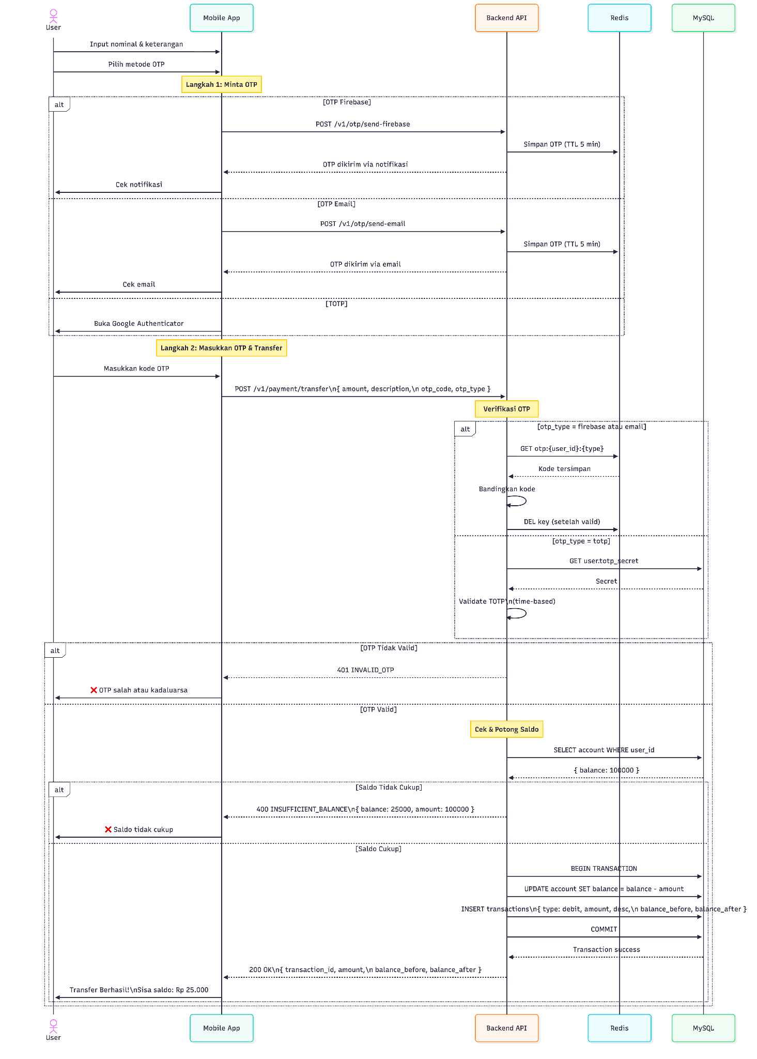

Install Redis

Opsi 1 — Install Redis via Docker (Recommended)
Kalau sudah install Docker Desktop di Windows:

Pull image Redis:
docker pull redis

Jalankan Redis container:
docker run --name redis-server -p 6379:6379 -d redis

Test Redis:
docker exec -it redis-server redis-cli

Untuk persist data:
docker run --name redis-server \
-p 6379:6379 \
-v redis-data:/data \
-d redis redis-server --appendonly yes

Opsi 1 — Native Windows (Cepat untuk testing)
Ada fork Windows-compatible:
Memurai redis for windows : https://www.memurai.com/get-memurai
Atau unofficial binary:
Redis Windows Port Github : https://github.com/tporadowski/redis/releases
Download Redis-x64.zip, extract lalu:

Start server:
redis-server.exe

Open CLI
redis-cli.exe

Test
ping

Notes :
Tambahkan file .env pada backend e-money service

.env
# Server
PORT=8080

# Database MySQL
DB_HOST=localhost
DB_PORT=3306
DB_USER=useremoney
DB_PASSWORD='Password#123'
DB_NAME=emoney

# Redis
REDIS_HOST=localhost
REDIS_PORT=6379
REDIS_PASSWORD=

# JWT
JWT_SECRET=your-super-secret-jwt-key-change-this

# Firebase
FIREBASE_CREDENTIALS_PATH=firebase_service_account.json

# SMTP Email
SMTP_HOST=smtp.gmail.com
SMTP_PORT=587
SMTP_USER=useremail@gmail.com
SMTP_PASSWORD=sesuai-setup-pada-gmail
SMTP_FROM=useremail@gmail.com
SMTP_FROM_NAME=E-Money App

# OTP
OTP_EXPIRY_MINUTES=5

Menjalankan Aplikasi Backend e-money Service
Sebelum menjalankan backend :
- Database mysql sudah dibuat nama database emoney
- Redis telah di Install
- Firebase key sdh di download
Extrax file zip buka menggunakan vscode dan tambahkan file .env

Start server:
go run main.go

Output setelh menjalankan
go run main.go

[GIN-debug] GET /v1/health --> emoney-2fa/handlers.HealthCheck (3 handlers)
[GIN-debug] POST /v1/auth/verify-token --> emoney-2fa/handlers.(*AuthHandler).VerifyToken-fm (3 handlers)
[GIN-debug] GET /v1/auth/me --> emoney-2fa/handlers.(*AuthHandler).Me-fm (4 handlers)
[GIN-debug] PUT /v1/auth/fcm-token --> emoney-2fa/handlers.(*AuthHandler).UpdateFCMToken-fm (4 handlers)
[GIN-debug] POST /v1/otp/send-firebase --> emoney-2fa/handlers.(*OTPHandler).SendFirebaseOTP-fm (4 handlers)
[GIN-debug] POST /v1/otp/send-email --> emoney-2fa/handlers.(*OTPHandler).SendEmailOTP-fm (4 handlers)
[GIN-debug] POST /v1/otp/confirm --> emoney-2fa/handlers.(*OTPHandler).ConfirmOTP-fm (4 handlers)
[GIN-debug] POST /v1/otp/totp/register --> emoney-2fa/handlers.(*OTPHandler).RegisterTOTP-fm (4 handlers)
[GIN-debug] POST /v1/otp/totp/verify --> emoney-2fa/handlers.(*OTPHandler).VerifyTOTP-fm (4 handlers)
[GIN-debug] GET /v1/account --> emoney-2fa/handlers.(*PaymentHandler).GetAccount-fm (4 handlers)
[GIN-debug] GET /v1/account/transactions --> emoney-2fa/handlers.(*PaymentHandler).GetTransactions-fm (4 handlers)
[GIN-debug] POST /v1/payment/topup --> emoney-2fa/handlers.(*PaymentHandler).TopUp-fm (4 handlers)
[GIN-debug] POST /v1/payment/transfer --> emoney-2fa/handlers.(*PaymentHandler).Transfer-fm (4 handlers)
2026/05/22 19:51:18 Server running on port 8080
[GIN-debug] [WARNING] You trusted all proxies, this is NOT safe. We recommend you to set a value.
Please check https://pkg.go.dev/github.com/gin-gonic/gin#readme-don-t-trust-all-proxies for details.
[GIN-debug] Listening and serving HTTP on :8080

Setelah semua step diatas berhasil, baru implementasi Flutter!
Postman = Blueprint. Flutter = Implementasi.

